**ALEXANDER FREY ON CD AND DVD**

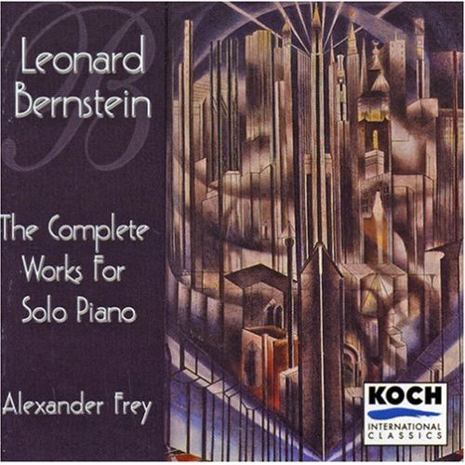  ***BERNSTEIN: Complete Works for Solo Piano* Alexander Frey, pianist *KOCH International Classics CD***

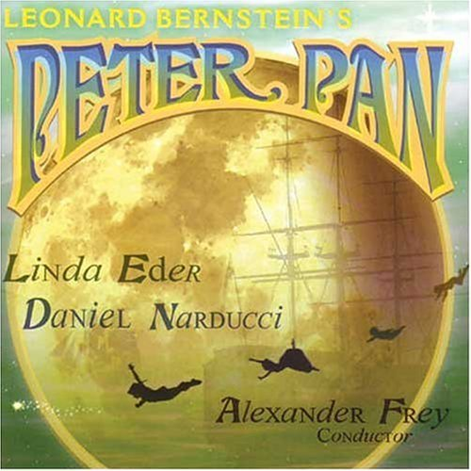  ***BERNSTEIN: PETER PAN (World Premiere Recording of the Complete Score)* Soloists, chorus and orchestra conducted by Alexander Frey Complete score restored and edited by Alexander Frey *KOCH International Classics CD***

  **IL ROVESCIA DELLA MEDAGLIA: *TRIBAL DOMESTIC*  Orchestra Filharmonica Calabrese (Calabria Philharmonic Orchestra) and soloists Alexander Frey, conductor *SONY MUSIC CD***

***Alexander Frey on CD and DVD (continued)***

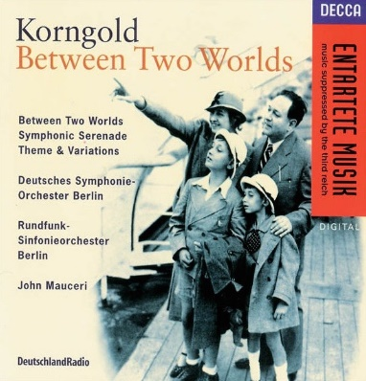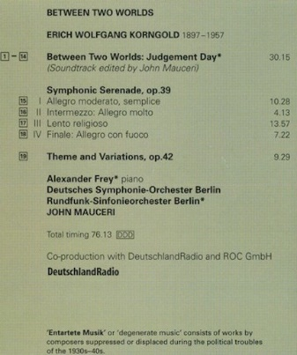  ***KORNGOLD: Between Two Worlds (Suite for Piano and Orchestra)* Alexander Frey, pianist Rundfunk-Sinfonie Orchester Berlin John Mauceri, Conductor *DECCA CD***

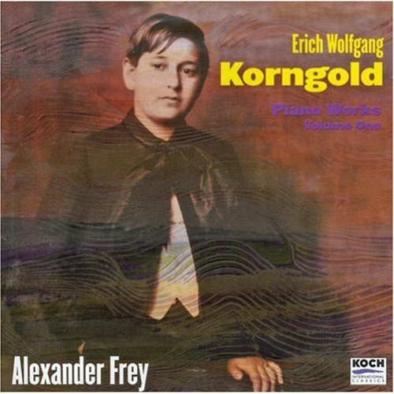



***KORNGOLD: Complete Piano Works, vol. 1* Alexander Frey, pianist *KOCH International Classics CD***

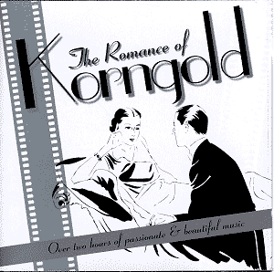 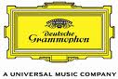 ***THE ROMANCE OF KORNGOLD* Alexander Frey, pianist, and various other artists *DEUTSCHE GRAMMOPHON CD***

***Alexander Frey on CD and DVD (continued)***

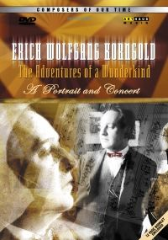 images-9

***Erich Wolfgang Korngold-The Adventures of a Wunderkind: A Portrait and Concert* Alexander Frey, pianist Anne Sofie von Otter, mezzo-soprano Leonidas Kavakos, violin Frankfurt Radio Symphony Orchestra Hugh Wolff, conductor *ARTE DVD (distributed by NAXOS)***

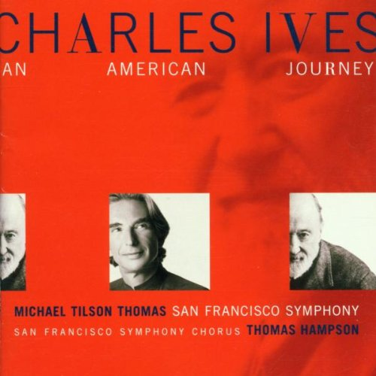  ***IVES: AN AMERICAN JOURNEY Includes the Fugue for organ and orchestra from Symphony no. 4 (Live Performance)* Alexander Frey, organist San Francisco Symphony Michael Tilson Thomas, conductor *RCA RED SEAL CD***

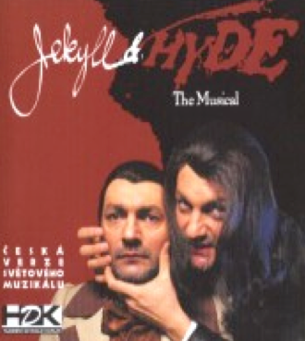 ***WILDHORN: Jekyll and Hyde* Karlin Theater Symphony Orchestra, Soloists and Chorus (Prague) Alexander Frey, conductor *HDK CD (distributed by Warner Brothers Music)***

***Alexander Frey on CD and DVD (continued)***

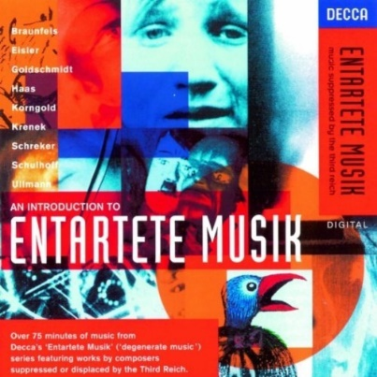   ***AN INTRODUCTION TO ENTARTETE MUSIK* Alexander Frey, pianist, and various other artists *DECCA CD***

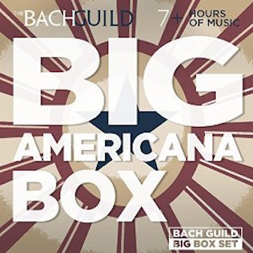   ***BIG AMERICANA BOX* Alexander Frey, pianist (solo piano works of Leonard Bernstein), and other artists. *BACH GUILD CD***

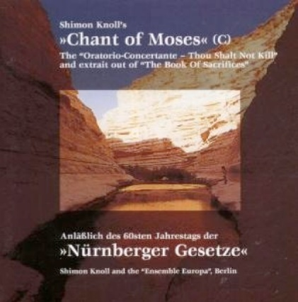 ***KNOLL: Chant of Moses and Selected Works* Ensemble Europa (Members of the Israel Philharmonic and Deutsche Oper orchestras) Alexander Frey, conductor and pianist** ***POOL CD Alexander Frey***